3 pointers for affordable healthy living in Singapore
Achieve wellness on a budget with these affordable healthy living tips.
3 Nov 2023
SOURCE: CPF Board


Healthy living in Singapore does not have to come with a hefty price tag. There are plenty of ways to pursue healthy living without stretching your finances.

From ways to exercise without spending a single cent to healthy cooking tips, read on to learn more about these cost-effective pointers for affordable healthy living in Singapore.

1. A healthy diet does not need to be expensive

A common misconception is that healthy eating is expensive. Think Genetically Modified Foods (GMO) foods, premium meat cuts, and lavish green smoothies. But in reality, affordable healthy eating is more about mindful choices than extravagant expenses.

Here are some tips to keep in mind whether you are dining in or out:
Dining in
Cooking your own meals is the best way to eat clean and cheaply. For example, an egg from the supermarket costs $0.40, while a soft-boiled egg at a coffee shop would cost more than double the price!

The thing about cooking at home is that you do not need to be a master chef to whip up a delicious and nutritious meal. There are plenty of resources available online, such as YouTube tutorials to help you master basic culinary skills.

If you prefer learning from someone, you can also spend a weekend learning from your loved ones who cook. It's a great way to bond and learn new skills at the same time.

Here are a few quick pointers for affordable healthy living when cooking at home:
- Invest in pantry staples like herbs, spices, and high-quality soy sauce. These ingredients not only enhance flavour but also reduce the need for salt, making your meals both delicious and healthier.
- Buy in bulk and prep your meals in advanced for fuss-free lunches.
- Learn to prepare healthy and versatile sauces such as pesto and teriyaki. These sauces are much lower in sodium than the store-bought variants and are free of preservatives. What’s more, they go great with a variety of meats and carbohydrates and are easy to whip up!
- Keep an eye for food items that are labelled “reduced-to-clear” in the supermarket. These are discounted items that are due to expire in the next few days but are still perfectly safe to consume.
Dining out
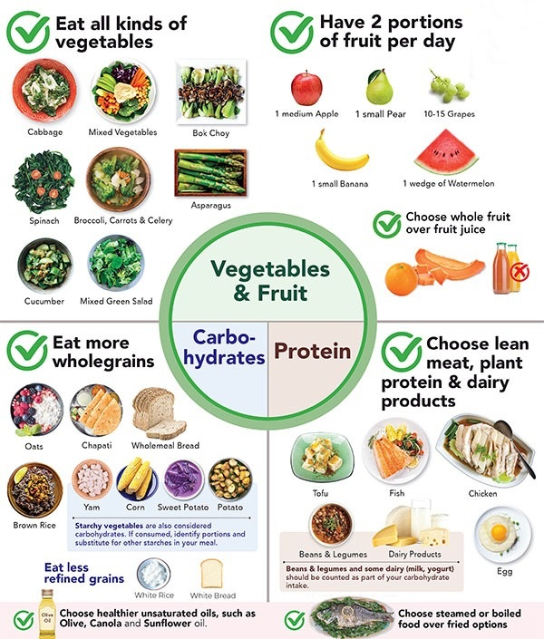
Source: Health Exchange
While eating out is understandably more expensive than cooking at home, it does not have to be an artery-clogging experience. The key is to understand nutrition and the elements of a balanced diet.

For starters, make sure you get two servings of vegetables a day. While local favourites like Hainanese Chicken Rice and Char Kway Teow are not known for their vegetables, you can always ask for extra greens in your meal. The additional cost is usually minimal!

According to the Health Promotion Board, aim to consume the following foods and servings each day:
- Half of your plate with fruits and two servings of vegetables
- Quarter of your plate with wholegrains (rice and alternatives)
- Quarter of your plate with meat and alternatives
The Health Promotion Board also recommends that you choose steamed or boiled food over fried options. This does not mean that you can no longer sink your teeth into crispy fried chicken again. The key is to eat everything in moderation – which means that you can treat yourself from time to time!

Keep your muscles active with regular exercise
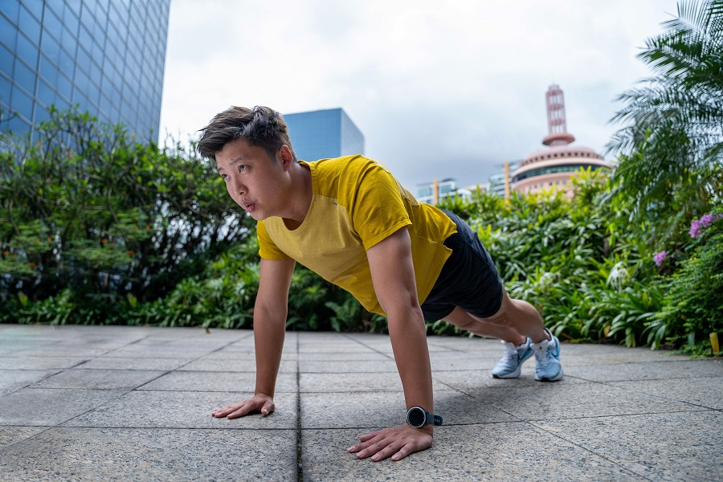
Your muscles and bones are living tissues that need to be worked regularly to maintain optimal performance. Don’t forget that the heart is also a muscular organ and needs regular exercise to stay strong and healthy too!

You do not need to spend a lot of money on a private gym membership to stay fit and active. There are plenty of ways to keep fit without spending a single dollar.
Light strolls in the park
If you are just starting out to get active, start slowly with light strolls in the park. The key is not to overexert yourself and go at your own pace. Taking any steps to get fit is an achievement itself!
Free ActiveSG Memberships
You can sign up for a free ActiveSG membership to receive $100 in credits. These can be used for access to public swimming complexes and gym admissions, as well as booking ActiveSG sport facilities, among others.
Home workouts
Home workouts have become increasingly popular in recent years, and you can do them in the comforts of your own home whenever you like.

If you are new to home workouts, check out these easy-to-follow 30-minute workout sessions by ActiveSG.

Once you start feeling confident, try including calisthenics in your fitness routine. Calisthenics are exercises that use your body weight to develop strength, endurance, and body coordination. Some examples of calisthenics include push ups, planks, and squats.

The best part about calisthenics is you do not need any fancy equipment. Most of the things you need, if any at all, can be found in your house.

3. Don’t forget your medical checkups

While a balanced diet and regular exercise are important for healthy living, it is also vital to schedule regular checkups and screenings with your doctor.
Keep tabs on your general health with regular screening
Early detection of serious illnesses can go a long way in the long run, ensuring better and more cost-effective treatment.

Even if you feel healthy, it is still a good idea to go for annual health screenings. This helps ensure your body is in good condition and can detect potential health issues, like cancer, through markers and other indicators early.

Screen for Life is a national health screening programme that provides subsidised health checkups for Singapore Citizens. At $5 or less, eligible Singapore Citizens can get screening for cardiovascular disease, cervical cancer, and colorectal cancer at participating CHAS GP clinics islandwide. Separate subsidies for breast cancer screening are also available.

Manage chronic disease well and early
Chronic diseases like high blood pressure and diabetes may seem harmless, but they can lead to serious complications and costly medical bills in the future if not managed properly.

The Chronic Disease Management Programme (CDMP) covers 23 conditions, including osteoporosis, diabetes, and high blood pressure. Patients can receive chronic diseases management care at 1,250 GP clinics, polyclinics, public hospitals, and participating specialist clinics across Singapore.

MediSave can also be utilised to reduce outpatient expenses under the CDMP. Patients with complex conditions can tap $700 annually from their MediSave, while other non-complex conditions can use up to $500 annually. A cash co-payment of 15% applies for these treatments.

Key pointers for affordable healthy living in Singapore
There are many ways to live healthily without breaking the bank. Taking charge of your eating and exercise habits, along with regular checkups and screenings, can help you achieve a healthier and more sustainable lifestyle.

By embracing these pointers and making healthy living a priority, you can not only improve your overall well-being, but also potentially save on future healthcare expenses. Here’s to affordable healthy living!

The information provided in this article is accurate as of the date of publication.

